**Course Title :** Computer Networks

**Course Code :** CSE405

**Section :** (02)

**Semester :** Spring 2022

**Project Report**

**Project Name: Design a full-fledged network for an organization with multiple subnets**

**Submitted To**

Dr. Anisur Rahman

Associate Professor

Department of Computer Science and Engineering

East West University

**Submitted By**

Md. Jannatul Haq 2018-1-60-224

**Submission Date**

14/05/2022

**Title:**

Design a full-fledged network for an organization with multiple subnets.

**Abstract:**

The purpose of this project is to design a suitable network system for universities in developing countries such as the University of Professionals. The aim was to design a university network with 6 different campuses under the University of Professionals. The servers used for this network design are DHCP servers and DNS servers.

**Objectives:**

* To learn how CISCO packer Tracer can be used.
* We can learn how to build a complex network with multiple subnets with dynamic Routing Algorithms.
* To get an idea of how a real-life network can be implemented.
* Provide IP by only one DHCP server.

**Introduction:**

A computer network represents a component, especially in how it enhances the functional performance in different fields and organizations, such as companies and universities. There are many components under a network such as a host, switch, router, laptop, smartphone, servers, wireless access point, etc.

*A host ("network host") is a computer or other device that communicates with other hosts on a network. Hosts on a network include*[*clients and servers*](https://www.techtarget.com/searchnetworking/definition/client-server)*-- that send or receive data, services, or applications.* [1] Every host has a unique IP address to communicate.

A switch connects devices such as routers, computers, and wireless access points.

*In*[*computer networking*](https://en.wikipedia.org/wiki/Computer_networking_device)*, a****wireless access point****(****WAP****), or more generally just an* ***access point****(****AP****), is a*[*networking hardware*](https://en.wikipedia.org/wiki/Networking_hardware)*device that allows other*[*Wi-Fi*](https://en.wikipedia.org/wiki/Wi-Fi)*devices to connect to a wired network*.[2]

In this project wired and wireless devices are connected to a network. It shows how a university website looks like and how university servers can be handled.

**Project Statement:**

This is mini project on University of Professionals is an enterprise that owns many computers, with a complex network infrastructure. Apart from wired internet access to all the classrooms, labs, employee PCs, library and other administrative and academic wings, the university also provides wireless internet access for everyone. On top of that the university runs several complex networked systems to support several of its business process like admissions, advising, results, tender, library management, accounts and so on.

**Tasks:**

The task is to create a complete model of a complex network by discovering the interconnectivity of the systems and sub-network, which will reflect the University of Professional’s structure and facilities, and features within the network. Use DNS servers and use only one DHCP to give an IP address to whole network components.

**Design Specification:**

I have created a complex network design by using the CISCO Packet Tracer simulation tool for the University of Professionals. I have used so many components to create this network.

**Used Components:**

* Switch (2960)
* PT-Router
* Access Point-PT (AP-PT)
* PC (end device)
* Smart Phone
* Laptop (wireless)
* Server-PT (DHCP)
* Server-PT (DNS)
* Server-PT (web.internationalapollo.edu)
* Printer-PT

The shortest specifications are given below:

**Routers (Campuses):**

A router is a switching device for networks, which can route network packets, based on their addresses, to other networks or devices. A router has a physical layer, data-link layer, and network layer. In this project, I used 6 PT-Routers to connect all the 6 campuses. And to connect the routers I have used Serial DCE connections.

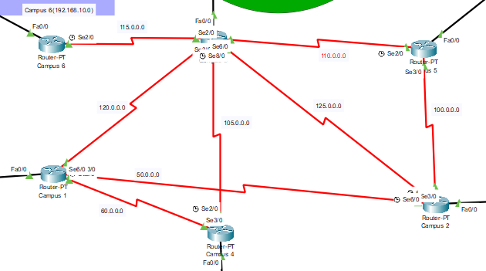

Figure 1: 6 Routers (Campus) of University of Professionals

**Server:**

In the network, server process request which is came from clients. I have used 3 different servers to establish connections between campuses. A single DHCP for providing an IP address to all the networks, 6 DNS servers for each campus, and 1 web server.

* **Web Server:** As instructed I take a web server to get entry into the University of Professional’s web page. Every client needs to type “www.professionals.edu” to enter the website of this University.

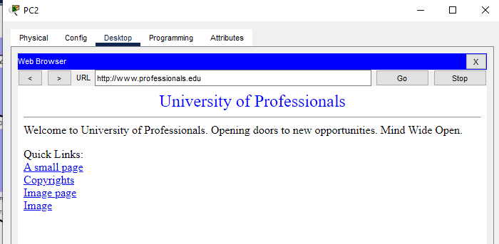

Figure 2: University of Professional’s Web Page

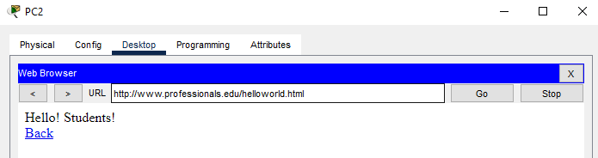

Figure 3: University of Professional’s Web Page Small Page

* **DHCP Server:** I have used only one DHCP to provide IP address, DNS server address and subnet mask IP to all the PC’s, Laptops, Smartphones.

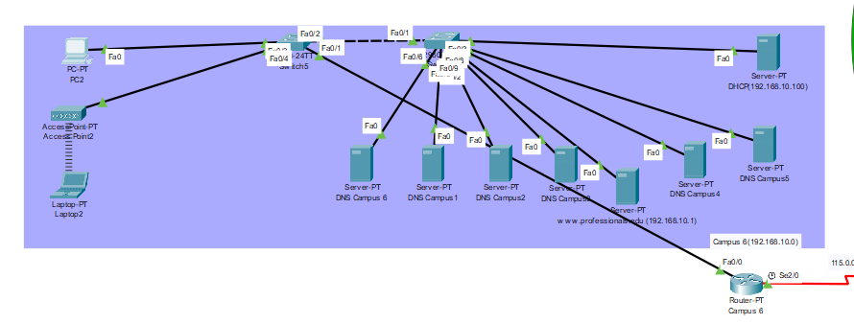

Figure 4: Server Room in Campus 6

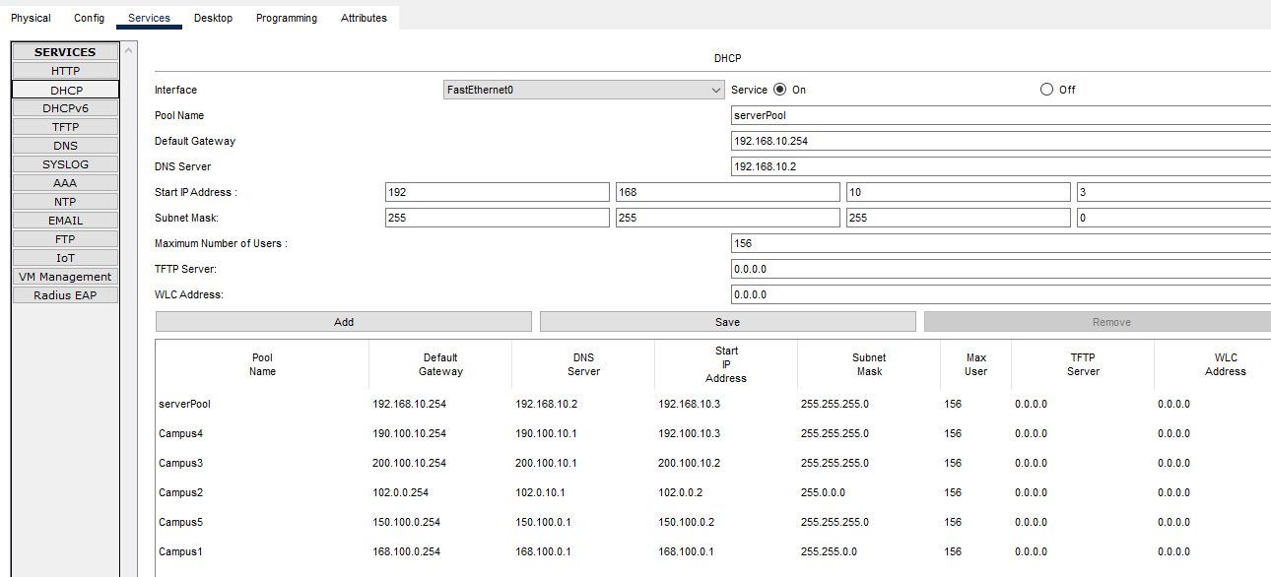

Figure 5: DHCP Server.

For DHCP and DNS configuration type in every router CLI:

enable

config

interface fa0/0

ip dhcp pool campus4

dns-server 150.100.10.1

network 150.100.0.254 255.255.255.0

exit

**DNS Server:** I have used 6 DNS servers for 6 campuses into a server room (network of campus 6). And the URL (http://www.professionals.edu) against the web server IP address

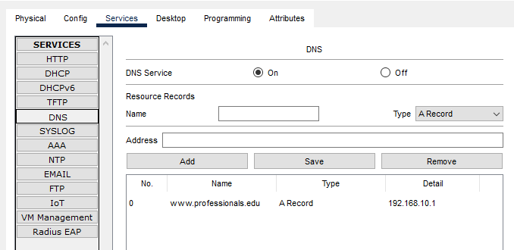

Figure 6: DNS Server.

**Wireless Devices:**

A wireless device is a device which connects devices to a network or sub-network without wire connection. In this project I have used 4 wireless devices (laptop, smartphone, pc, and printer) through the Access Point Wireless device.

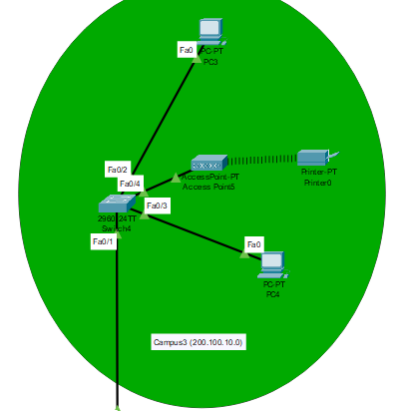

Figure7: Wireless Printer.

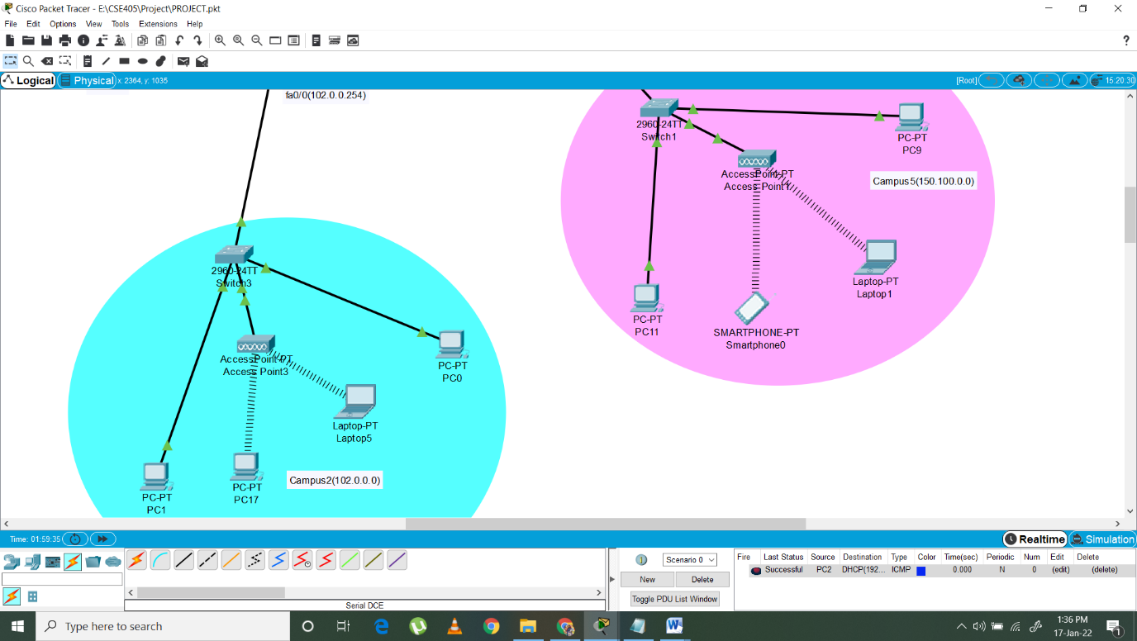

Figure 8: Wireless Laptop, PC, Smartphone.

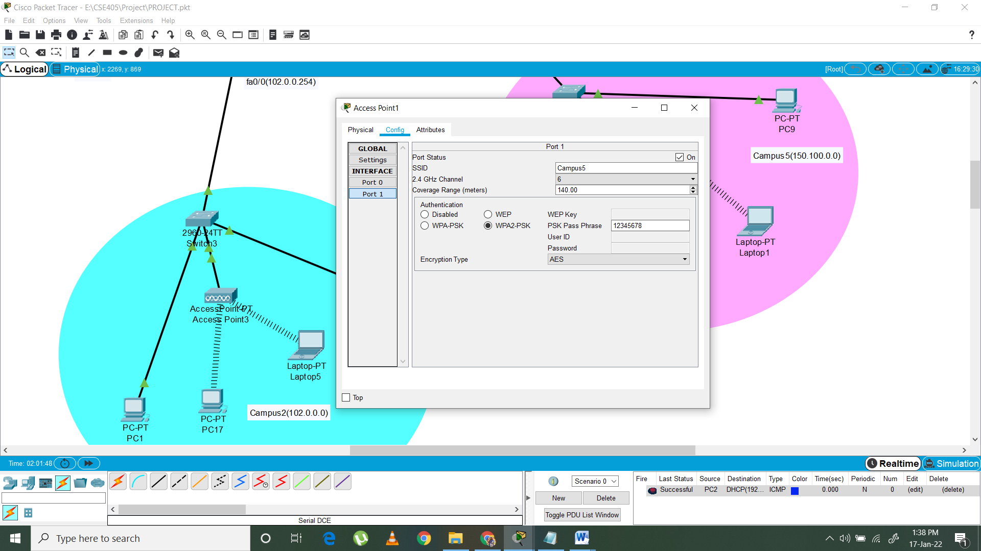

Figure 9: Access Point-PT.

**Lines of codes:**

For Router Configuration-

**Campus 1:**

interface fa0/0

ip address 168.100.0.254 255.255.0.0

no shut

do wr

exit

interface se2/0

ip address 60.0.0.1 255.0.0.0

clock rate 64000

no shut

do wr

exit

interface se6/0

ip address 120.0.0.1 255.0.0.0

no shut

do wr

exit

interface se3/0

ip address 50.0.0.2 255.0.0.0

clock rate 64000

no shut

do wr

exit

**Routing Table:**

ip route 190.100.10.0 255.255.255.0 60.0.0.2

ip route 105.0.0.0 255.0.0.0 60.0.0.2

ip route 102.0.0.0 255.0.0.0 50.0.0.1

ip route 110.0.0.0 255.0.0.0 120.0.0.2

ip route 100.0.0.0 255.0.0.0 50.0.0.1

ip route 115.0.0.0 255.0.0.0 120.0.0.2

ip route 192.168.10.0 255.255.255.0 120.0.0.2

ip route 125.0.0.0 255.0.0.0 50.0.0.1

ip route 150.100.0.0 255.255.0.0 50.0.0.1

**Campus 2:**

interface fa0/0

ip address 102.0.0.254 255.0.0.0

no shut

do wr

exit

interface se2/0

ip address 100.0.0.2 255.0.0.0

clock rate 64000

no shut

do wr

exit

interface se3/0

ip address 50.0.0.1 255.0.0.0

no shut

do wr

exit

interface se6/0

ip address 125.0.0.1 255.0.0.0

clock rate 64000

no shut

do wr

exit

**Routing Table:**

ip route 150.100.0.0 255.255.0.0 100.0.0.1

ip route 110.0.0.0 255.0.0.0 100.0.0.1

ip route 115.0.0.0 255.0.0.0 125.0.0.2

ip route 192.168.10.0 255.255.255.0 125.0.0.2

ip route 105.0.0.0 255.0.0.0 125.0.0.2

ip route 190.100.10.0 255.255.255.0 125.0.0.2

ip route 60.0.0.0 255.0.0.0 50.0.0.2

ip route 168.100.0.0 255.255.0.0 50.0.0.2

ip route 120.0.0.0 255.0.0.0 50.0.0.2

**Campus 3:**

interface fa0/0

ip address 200.100.10.0 255.255.255.0

no shut

do wr

exit

interface se3/0

ip address 105.0.0.2 255.0.0.0

no shut

do wr

exit

interface se2/0

ip address 115.0.0.2 255.0.0.0

no shut

do wr

exit

interface se6/0

ip address 110.0.0.2 255.0.0.0

no shut

do wr

exit

interface se7/0

ip address 120.0.0.2 255.0.0.0

clock rate 64000

no shut

do wr

exit

interface se8/0

ip address 125.0.0.2 255.0.0.0

no shut

do wr

exit

**Routing Table:**

ip route 192.168.10.0 255.255.255.0 115.0.0.1

ip route 190.100.10.0 255.255.255.0 105.0.0.1

ip route 60.0.0.0 255.0.0.0 120.0.0.1

ip route 168.100.0.0 255.255.0.0 120.0.0.1

ip route 50.0.0.0 255.0.0.0 120.0.0.1

ip route 102.0.0.0 255.0.0.0 125.0.0.1

ip route 100.0.0.0 255.0.0.0 110.0.0.1

ip route 150.100.0.0 255.255.0.0 110.0.0.1

**Campus 4:**

interface fa0/0

ip address 190.100.10.254 255.255.255.0

no shut

do wr

exit

interface se3/0

ip address 60.0.0.2 255.0.0.0

no shut

do wr

exit

interface se2/0

ip address 105.0.0.1 255.0.0.0

clock rate 64000

no shut

do wr

exit

**Routing Table:**

ip route 168.100.0.0 255.255.0.0 60.0.0.1

ip route 120.0.0.0 255.0.0.0 60.0.0.1

ip route 115.0.0.0 255.0.0.0 105.0.0.2

ip route 192.168.10.0 255.255.255.0 105.0.0.2

ip route 50.0.0.0 255.0.0.0 60.0.0.1

ip route 125.0.0.0 255.0.0.0 105.0.0.2

ip route 110.0.0.0 255.0.0.0 105.0.0.2

ip route 100.0.0.0 255.0.0.0 105.0.0.2

ip route 102.0.0.0 255.0.0.0 60.0.0.1

ip route 150.100.0.0 255.255.0.0 105.0.0.2

**Campus 5:**

interface fa0/0

ip address 150.100.0.254 255.255.0.0

no shut

do wr

exit

interface se3/0

ip address 100.0.0.1 255.0.0.0

no shut

do wr

exit

interface se2/0

ip address 110.0.0.1 255.0.0.0

clock rate 64000

no shut

do wr

exit

**Routing Table:**

ip route 192.168.10.0 255.255.255.0 110.0.0.2

ip route 115.0.0.0 255.0.0.0 110.0.0.2

ip route 190.100.10.0 255.255.255.0 110.0.0.2

ip route 105.0.0.0 255.0.0.0 110.0.0.2

ip route 60.0.0.0 255.0.0.0 110.0.0.2

ip route 168.100.0.0 255.255.0.0 100.0.0.2

ip route 120.0.0.0 255.0.0.0 110.0.0.2

ip route 50.0.0.0 255.0.0.0 100.0.0.2

ip route 125.0.0.0 255.0.0.0 100.0.0.2

ip route 102.0.0.0 255.0.0.0 100.0.0.2

**Campus 6:**

interface fa0/0

ip address 192.168.10.254 255.255.255.0

no shut

do wr

exit

interface se2/0

ip address 115.0.0.1 255.0.0.0

clock rate 64000

no shut

do wr

exit

**Routing Table:**

ip route 190.100.10.0 255.255.255.0 115.0.0.2

ip route 105.0.0.0 255.0.0.0 115.0.0.2

ip route 60.0.0.0 255.0.0.0 115.0.0.2

ip route 168.100.0.0 255.255.0.0 115.0.0.2

ip route 120.0.0.0 255.0.0.0 115.0.0.2

ip route 50.0.0.0 255.0.0.0 115.0.0.2

ip route 125.0.0.0 255.0.0.0 115.0.0.2

ip route 102.0.0.0 255.0.0.0 115.0.0.2

ip route 100.0.0.0 255.0.0.0 115.0.0.2

ip route 150.100.0.0 255.255.0.0 115.0.0.2

ip route 110.0.0.0 255.0.0.0 115.0.0.2

ip route 150.100.10.0 255.255.255.0 115.0.0.2

ip route 200.100.10.0 255.255.255.0 115.0.0.2

**Diagram:**

Figure 10: University of Professionals

All the campuses are given below-

**Campus 1:** Two wired PCs, one wireless PC, and one wireless laptop

Figure11: Campus 1.

**Campus 2:** Two wired PCs, one wireless PC and one wireless laptop.

Figure 12: Campus 2.

**Campus 3:** Two wired PCs and one wireless printer are connected through the access point.

Figure 13: Campus 3

**Campus 4:** Three wired PCs, one wireless laptop, and one smartphone.

Figure 14: Campus 4.

**Campus 5:** Two wired PCs, one wireless laptop, and one smartphone.

Figure 15: Campus 5.

**Campus 6:** One wired PC, one wireless laptop, two switches, and 8 different servers.

Figure 16: Campus 6.

All the packets are successfully transferred.

Figure 17: Sending Packets Successful

**Limitations and Future Expansion:**

**Limitations:**

Hosts are not getting the default gateway. It is creating problems.

**Future Plan:**

* Give default gateway to every host.
* Use Email address.
* Cloud for store information.
* A private network that only can be accessed by giving the password. (Security device)
* I will try to create classrooms on every campus and use wireless/wired ceiling fans, ACs, lights, smoke detectors, doors, etc.

A future planned diagram is given below-

Figure 18: Future Work Diagram

**Conclusion:**

I learned how to develop a complex network for a university. While designing I ran across some difficulties, and I have overcome some of them with help of lectures and the internet. I have followed all the instructions given in the problem statement. Such as I take the IP address from 3 different classes, used a single DHCP server, used wired and wireless devices, the connection has been established among the host in a network, and a server room that contains all the servers of the university. After all, I can say that I am successful to create a network for University of Professionals though still there are some problems that can be solved by someone’s acknowledgment and that will be done in the future.

**Reference:**

[1]. <https://www.techtarget.com/searchnetworking/definition/host>

[2]. <https://en.wikipedia.org/wiki/Wireless_access_point>